Welcome to Bethesda Christian Fellowship
Sunday, April 14th, 2019
Visit Us Online – www.Bethesdacf.org or on
Facebook (Bethesda Christian Fellowship)

For our Guests:
*Welcome! We are blessed that you chose to Worship with us today. If you have any questions, please ask one of the ushers or someone from the Ministry Team. Ministry Team info is located on the back page of the bulletin.
*Children, ages 3-12, are welcome to go to Children’s church after our announcements.
*Rest rooms are in the hallway beside the kitchen.
*The Nursery is in the Kitchen.
*First-time visitors: We have a gift for you.
*If you would like to be a part of a Life group, please let someone on the Ministry Team know.
*We hope to see you again very soon!
********************************************************************
Sunday Morning Service: 9:30am
-Praise & Worship
-Announcements & Tithe (Tithe envelopes are available)
-Praise & Worship
-Message: Pastor Verlin Wenger
********************************************************************
Preaching next week: Communion Service (Message- Pastor Leroy Miller)
Preaching in 2 weeks: Pastor Leroy Miller
Children’s church teachers & assistants:
Teaching/Assisting today: (3-4), (5-7), (8-9), (10-12)

Teaching/Assisting next week: (3-4), (5-7), (8-9), (10-12)

********************************************************************
Birthdays This Week: Amanda Blank, Jonathan Fisher, Steven Fisher, Dawson Gehman, BeckiLynne Stoltzfus

Anniversaries This Week:
Announcements

Communion: Next Sunday, April 21st

Child Dedication Service: The date has been set for May 26th. If you would still like to be involved, please let one of the leaders know.

Men’s Night Out: This Friday evening is our Men’s Night Out. Raymond & Jada are in charge.

Foothills Ordination: Pastor Ron & Pastor Leroy, along with their wives, are in North Carolina for the ordination at Foothills Community Chapel. Please be in prayer for Foothills church as they journey through this transition.

Prayer for our Country: Let’s be in prayer for our leaders and pray that their hearts would be open to hear from the Lord for the direction of our country!
Therefore, I exhort first of all that supplications, prayers, intercessions, and giving of thanks be made for all men, 2. For kings and all who are in authority, that we may lead a quiet and peaceable life in all godliness and reverence. I Timothy 2:1-2
*********************************************************************
Sight & Sound: Let’s continue to pray that God would be glorified in everything they do, and many souls would be changed for the Glory of the Kingdom of Heaven!
Born To Be Different Productions: Let’s be in prayer for Matt & Nicole as they desire to establish a Christian-based, youth musical theater program that brings good, clean and inspiring entertainment for the whole family.
*********************************************************************
~Youth Announcements~
Tonight: Open evening

Wednesday Evening: Open evening
*********************************************************************
~Looking ahead~
May 1st: Foot washing & Family Fun Night
April 26th-28th: Gospel Express auction

Looking way ahead:
TBD: Business Meeting
June 20-23: Youth Alive 2019 * Learn more at http://youthaliveencounter.org
*********************************************************************
Offering last week: $3,200.00 Attendance Last Week: 235

Offering 2 weeks ago: $1,448.00 Attendance 2 Weeks Ago: 147

Sermon Notes:

________________________________________________________________

________________________________________________________________

________________________________________________________________

________________________________________________________________

________________________________________________________________

________________________________________________________________

________________________________________________________________

________________________________________________________________

________________________________________________________________

________________________________________________________________

________________________________________________________________

________________________________________________________________

________________________________________________________________

________________________________________________________________

________________________________________________________________

________________________________________________________________

Bethesda’s Ministry Team:
Senior Pastor: Leroy Miller (260)704-2446 (leroy@bethesdacf.org)
Associate Pastor: Verlin Wenger (717)799-4757 (verlin@bethesdacf.org)
Associate Pastor/Yth Pastor: Ron Yoder (717)723-0653 (Ronyoder71@gmail.com)
Deacon: Gary Hurst (717)475-8414 (GaryandKendra@icloud.com)
Overseer Team:
Jim Zimmerman (Chairman): (717)475-7858
Steve Stutzman: (828)817-3790
WELCOME
TO BETHESDA CHRISTIAN FELLOWSHIP

Our porches may be full but there’s always room
for one more at a “House of Mercy!”

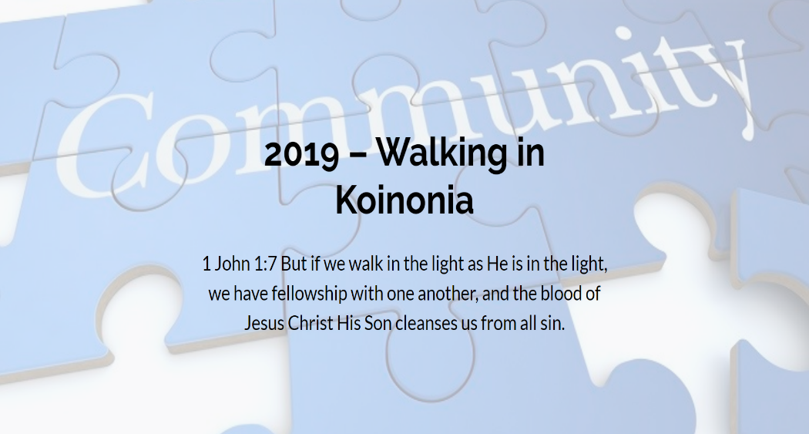
Pastor Verlin Wenger will be preaching in the message part of the service!
If you are a first-time guest, please read the inside cover of the bulletin for more info. We are so glad you could join us for our worship service today!

